eCommerce Store
Using OpenSource Readme

Created by:
Role/Organisation Unit | Name | Date
 | Gang Kong | 2021-08-16

History
Version / Date | Change
1.0/08/2021 | First version

Content
1. Background 3
2. Functional Description 3
3. Source Code 4
4. Platform architecture 4
5. Installation of solution 4
6. Program and Data Architecture 6
7. Key customizations 7
8. Roles 7

Background
Create an e-commerce store using 100% OpenSource technologies for a company with following characteristics
a. Selling 5 products – mobile phone, computer, tablet, battery pack and desktop
b. The above 5 products are sold from 3 supplier each – Asus, LG, Samsung
c. Delivery to Singapore and KL only
Technical assignment must be uploaded to a GitHub repository at least 2 days before the interview date.

Functional Description

Please review the following recording to know the functions from different roles.

- As a new user, you could register. Since we do not setup registration verification in the process, you could place order directly.
Video register.mp4 was deleted to control the file size and you could see the full document and video file in github repository.
As you could see, you could only choose Singapore or KL in the shipping address so it covers requirement c for delivery restriction.

- As a recurring customer, you could review the products and place orders and choose shipment method then do the payment online.
Video customer.mp4 was deleted to control the file size and you could see the full document and video file in github repository.

I made some program changes for this part so that the system will not validate the credit card to avoid inputting an actual credit card during testing.

- As a vendor, you could see a bar for ‘administration’ so that you could maintain the product catalogue from your end and might complete shipments for customers. However, all your authorizations are restricted to products and orders under your vendor only.
Video vendor.mp4 was deleted to control the file size and you could see the full document and video file in github repository.

In the initial design, vendor could deliver the goods no matter customers complete payment or not. Program changes were made in the source code so that vendor could only delivery after the order is paid.

- As an administrator, you could manage your customers, catalogue and orders. Besides, you might customize the platform per the variances provided by NopCommerce. You could install plugins from NopCommerce to have additional functions developed by third party or yourself.
Video administrator.mp4 was deleted to control the file size and you could see the full document and video file in github repository.

As you could see from the video,the product catalogue covers the product ranges as described in requirement a and they are supplied by 3 vendors per requirement b. Vendors could make the deliveries under his own scope which is shown in vendor.mp4.

Source Code
Source code and documents are stored in master branch of below Github repository:
https link: https://github.com/hi-birds/New-eCommerce.git
ssh: git@github.com:hi-birds/New-eCommerce.git

It includes:
- Source codes in sub directories.
- Database file from MySQL nop.sql
- Recording files in mp4 format in case that it is not readable in the word file.
- This document itself.
- Logo files for suppliers.

Platform architecture
I applied NopCommerce since it enables most requirements applying system configuration and it is open source so that I could modify the program per business requirements.

Here are some key features of NopCommerce Architecture
- Based on ASP.NET Core. At the foundation of nopCommerce lies one of the most popular and robust open-source frameworks which is backed by the ASP.NET team at Microsoft.
- Open-source. NopCommerce is community-driven. It is actively being developed and new features and improvements are added to it constantly.
- Extendable architecture. Developers can develop custom themes and plugins without interfering with the platform’s core architecture.
- RESTful API developed by Nop-Templates.

One key finding in the project is that there is a major framework upgrade from NopCommerce 4.3 to NopCommerce 4.4 so many local plugins do not work in the latest version so I downloaded the source code of NopCommerce 4.3 to start my developments after facing some failures in NopCommerce 4.4.

Installation of solution

Clone the source code from GitHub then open ‘NopCommerce.sln’ using Visual Studio 2019. It will start from presentation nop.Web to open a local page for installation. There are some requisitions including IIS, .net framework ,mvc and Database installations.

In the following screen, administrator authentication information should be defined and the connection details for database. I connected local MySQL database using raw connection string. PostgreSQL is supported in NopCommerce 4.4, but not in NopCommerce4.3.

A database ‘nop’ would be created in the server. And you might consider keeping a copy of it then import the data from my copy.

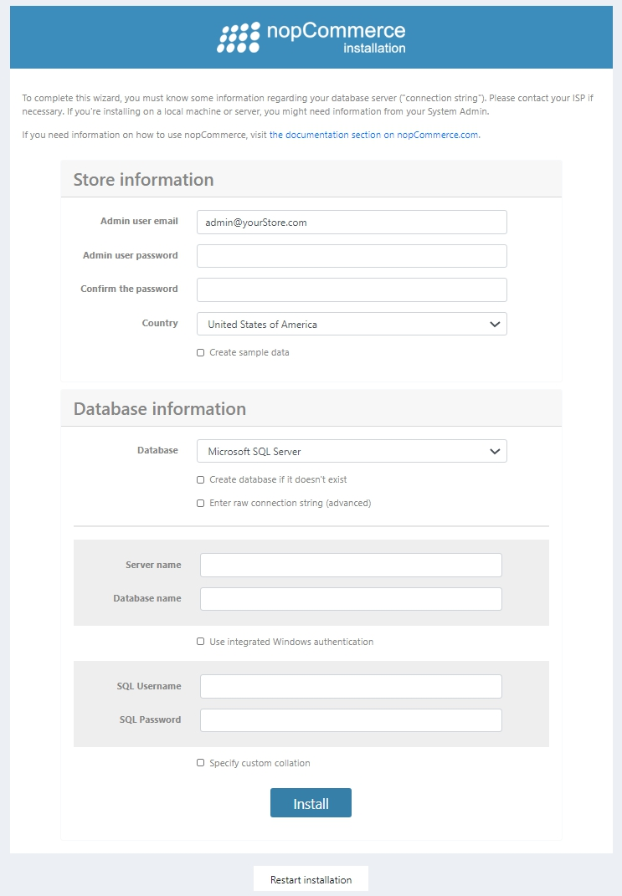

Program and Data Architecture

This is the structure of the project with 4 layers:
- Presentation: Nop.Web contains the store pages, an areas ‘Admin’ contain those views for administration function.Basic framework is in Nop.Web.Framework.
- Services: Nop.Services for the backend services.
- Data: Nop.Data includes data wharehouse implementation, ORM mapping and database initialization.
- Core: Nop.Core defines interfaces,infrastructure and so on. 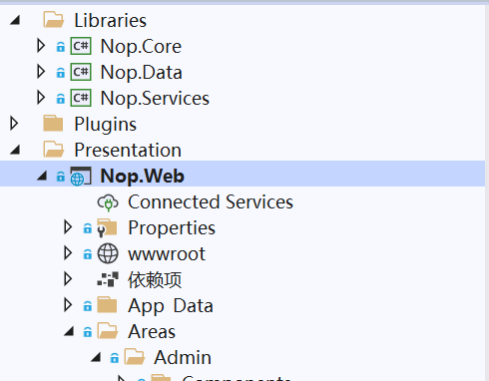

The structure in database nop is rather self-explained, like standard tables in CRM or ERP system.

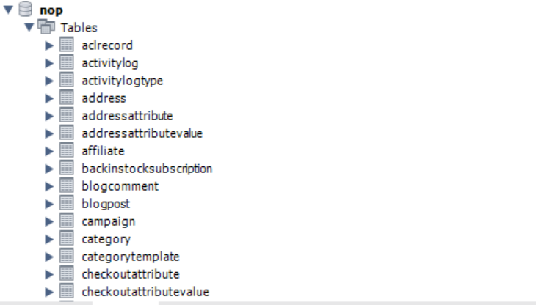

The frontend(views in Nop.Web) is using MVC razor framework and ajax for asynchoronized updates.
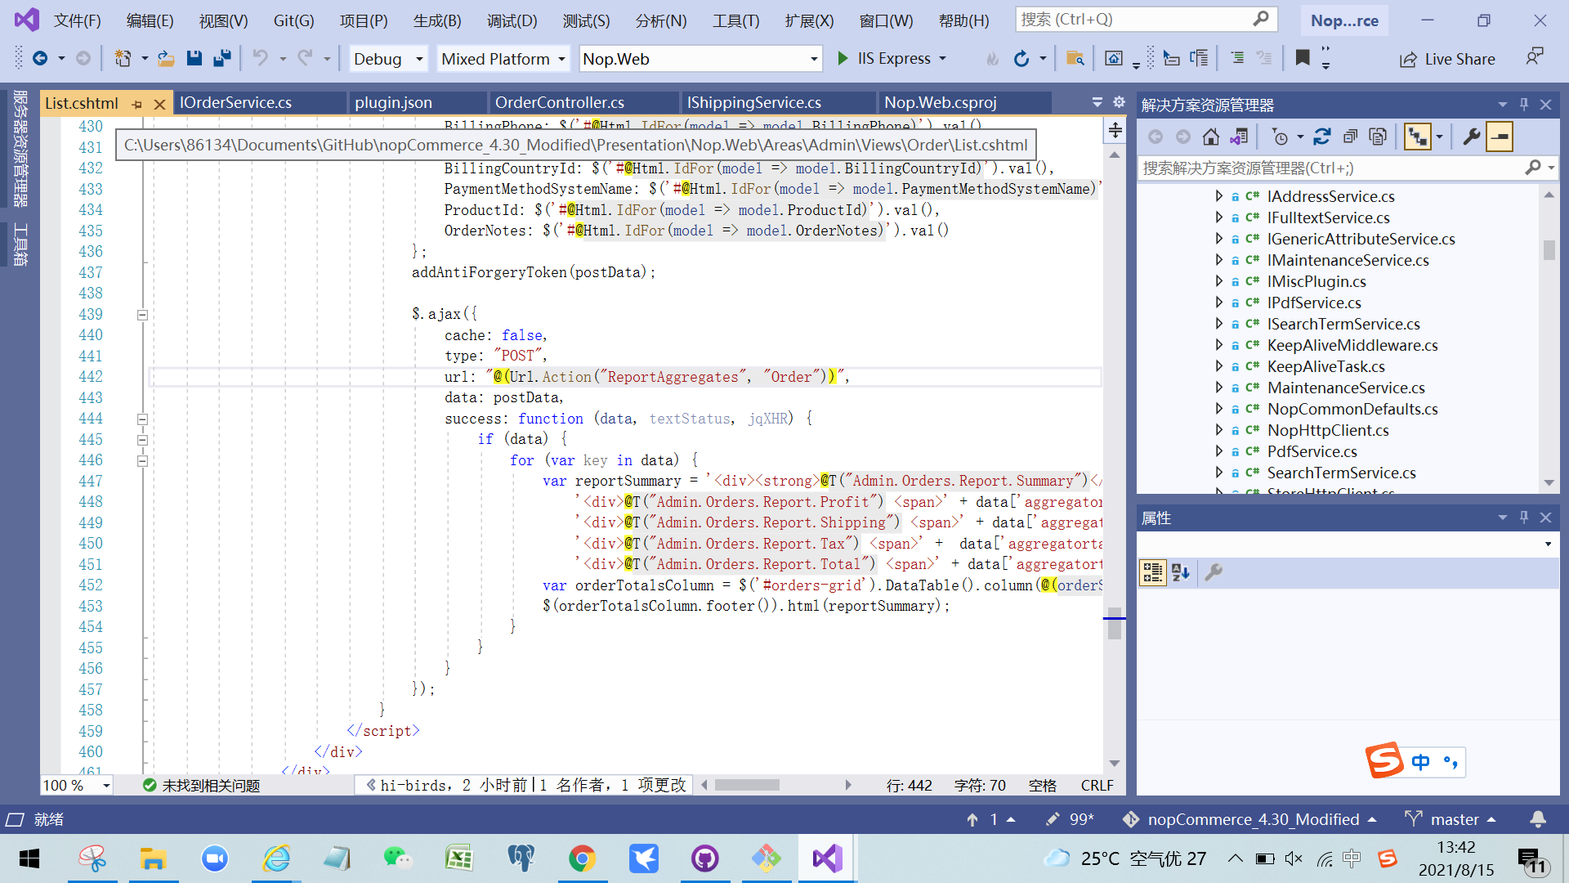

Then business logic is implemented in Nop.Service like below.
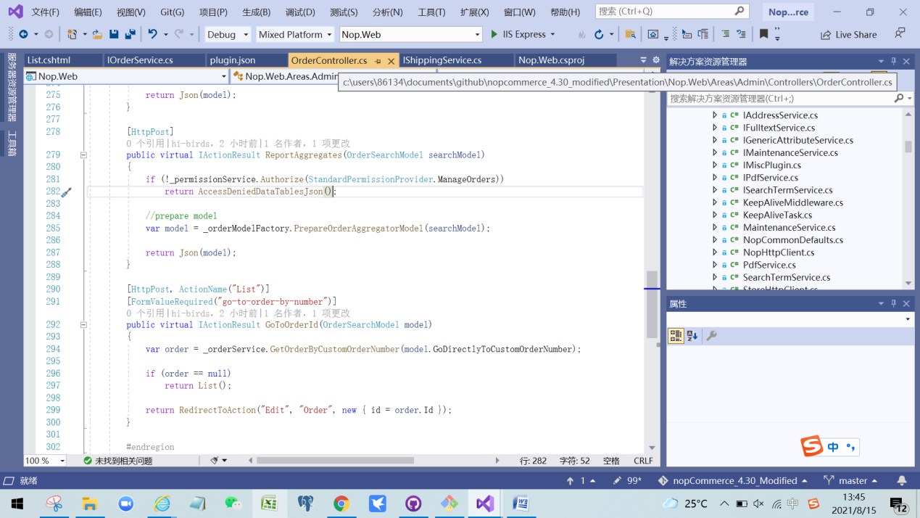

Key customizations
Key modifications were made to ensure the solutions aligned to requirements:
- Customer/catalogue management such as definition of vendors and product categories.
There is excel import function in catalogue but in long terms, it would be better to use web scraping then automate the import in a more systematic way.
- Layout/content change to align with the topic
- Configurations like country,currencies and measures. More configurations could be developed per business requirements.
- Installation of plugins then configure them. However some plugins are not free-of-charge in NopCommerce market place.
- Program modification to implement new business rules. At the moment, it fits most requirements without major changes.

Roles

Customer roles are rather simple now, not covering basic structure like ship-to,bill-to and payer partners.
